Test Cae 1 List Products: Verify that the system correctly displays all products in the inventory.

| Steps | Expected Results | Actual result |
| --- | --- | --- |
| Start the program | Should appear program options | Displayed all the options to run the program options |
| Select option 1 from the menu | All products in the inventory are listed, showing their details (ID, Name, Expiry Date, Price, Category) | Able to see the desirable options like (ID, Name, Expiry Date, Price, Category) |

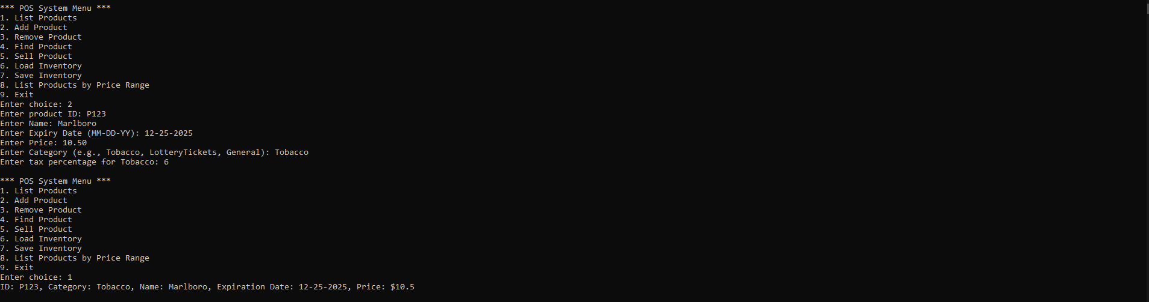

Test Case 2 Add Product: Confirm that the system allows adding a new product and displays it correctly.

| Steps | Expected Results | Actual result |
| --- | --- | --- |
| Start the program | Should appear program options | Displayed all the options to run the program options |
| Select option 2 from the menu  Confirm the addition | Enter details for a new product (ID, Name, Expiry Date, Price, Category, and any applicable taxes) | It should displayed all the details that has been added for new product |

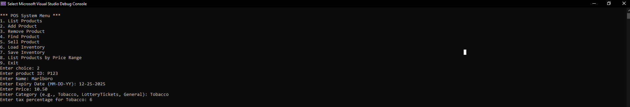

Test Case 3 Remove Product: Test the product removal functionality

| Steps | Expected Results | Actual result |
| --- | --- | --- |
| Start the program | Should appear program options | Displayed all the options to run the program options |
| Select option 3 from the menu  Enter the name of an existing product to remove | The product is removed successfully with a confirmation message. Subsequent viewing of inventory should not include this product | Able to see the desirable product has been removed successfully |

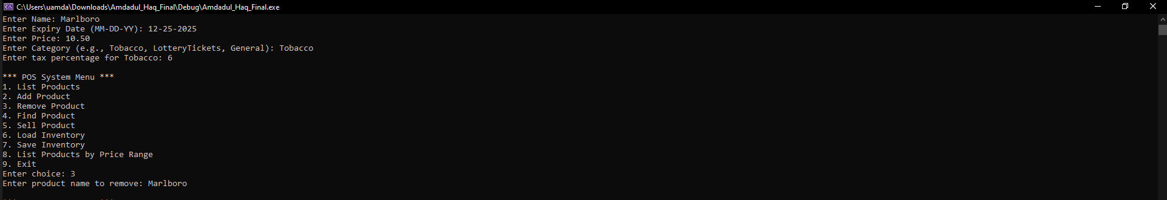

Test Case 4 Find Product: Ensure the system can locate a product by name

| Steps | Expected Results | Actual result |
| --- | --- | --- |
| Start the program | Should appear program options | Displayed all the options to run the program options |
| Select option 4 from the menu  Enter the name of the product to find | The details of the requested product are displayed | Should displayed the product that searched |

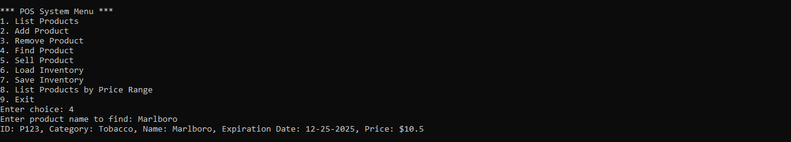

Test Case 5 Sell Product: Verify that the system can process a sale and display the correct price

| Steps | Expected Results | Actual result |
| --- | --- | --- |
| Start the program | Should appear program options | Displayed all the options to run the program options |
| Select option 5 from the menu  Enter the name of the product to sell | The selling price after applying any taxes is displayed | Should able to sell the product that are in inventory and displayed selling price |

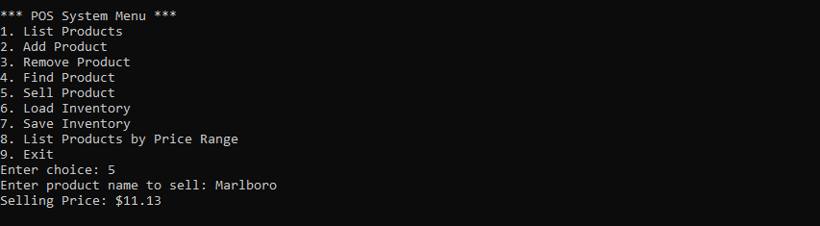

Test Case 6 Load Inventory: Test loading of inventory from a file

| Steps | Expected Results | Actual result |
| --- | --- | --- |
| Start the program | Should appear program options | Displayed all the options to run the program options |
| Select option 6 from the menu | Inventory is loaded from the file, and a success message is displayed | Displayed Inventory Load Successfully |

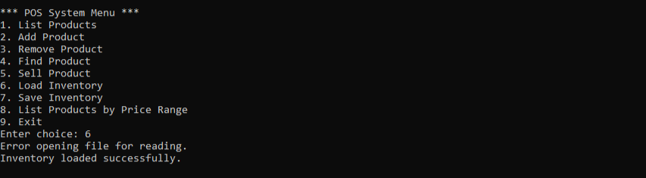

Test Case 7 Save Inventory: Ensure the inventory can be saved to a file correctly

| Steps | Expected Results | Actual result |
| --- | --- | --- |
| Start the program | Should appear program options | Displayed all the options to run the program options |
| Modify the inventory (add or remove products) | The current state of the inventory is saved, and a confirmation message is displayed. | Displayed the alert that inventory saved successfully |

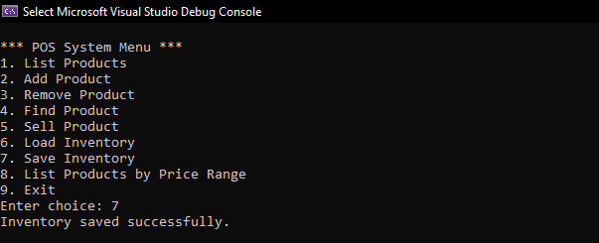

Test Case 8 List Products by Price Range: Confirm that products within a specific price range are correctly listed

| Steps | Expected Results | Actual result |
| --- | --- | --- |
| Start the program | Should appear program options | Displayed all the options to run the program options |
| Select option 8 from the menu  Enter the low and high price range | All products within the specified price range are displayed | Displayed the price ranged items which was entered |

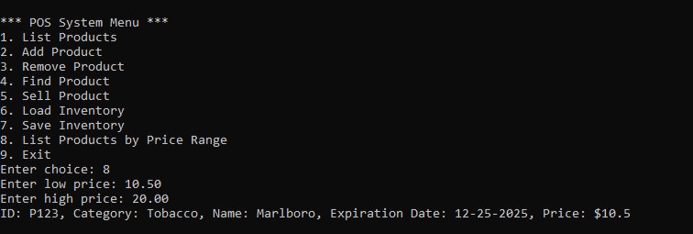

Test Case 9 Exit: Verify that the exit option closes the application smoothly

| Steps | Expected Results | Actual result |
| --- | --- | --- |
| Start the program | Should appear program options | Displayed all the options to run the program options |
| Select option 9 from the menu | The application closes without error | Displayed no error program exit |

